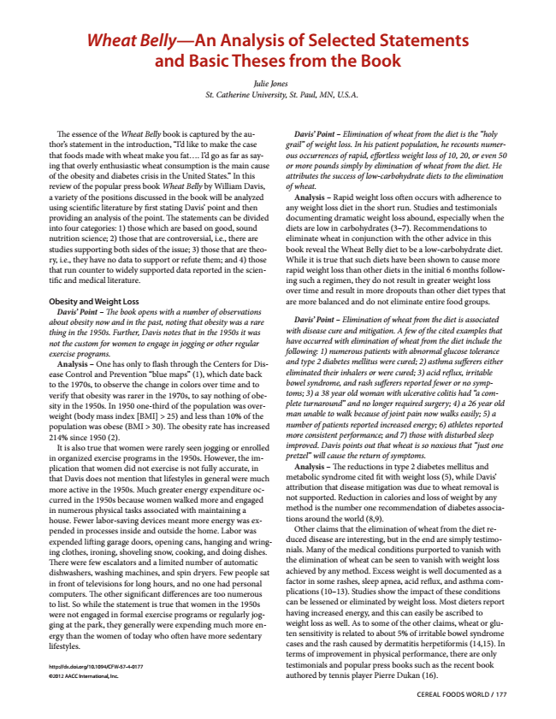
Wheat Belly—An Analysis of Selected Statements and Basic Theses from the Book
Julie Jones St. Catherine University, St. Paul, MN, U.S.A.
The essence of the Wheat Belly book is captured by the au-
Davis’ Point – Elimination of wheat from the diet is the “holy thor’s statement in the introduction, “I’d like to make the case
grail” of weight loss. In his patient population, he recounts numer- that foods made with wheat make you fat.... I’d go as far as say-
ous occurrences of rapid, effortless weight loss of 10, 20, or even 50 ing that overly enthusiastic wheat consumption is the main cause
or more pounds simply by elimination of wheat from the diet. He of the obesity and diabetes crisis in the United States.” In this
attributes the success of low-carbohydrate diets to the elimination review of the popular press book Wheat Belly by William Davis,
of wheat. a variety of the positions discussed in the book will be analyzed
Analysis – Rapid weight loss often occurs with adherence to using scientific literature by first stating Davis’ point and then
any weight loss diet in the short run. Studies and testimonials providing an analysis of the point. The statements can be divided
documenting dramatic weight loss abound, especially when the into four categories: 1) those which are based on good, sound
diets are low in carbohydrates (3–7). Recommendations to nutrition science; 2) those that are controversial, i.e., there are
eliminate wheat in conjunction with the other advice in this studies supporting both sides of the issue; 3) those that are theo-
book reveal the Wheat Belly diet to be a low-carbohydrate diet. ry, i.e., they have no data to support or refute them; and 4) those
While it is true that such diets have been shown to cause more that run counter to widely supported data reported in the scien-
rapid weight loss than other diets in the initial 6 months follow- tific and medical literature.
ing such a regimen, they do not result in greater weight loss over time and result in more dropouts than other diet types that Obesity and Weight Loss
are more balanced and do not eliminate entire food groups. Davis’ Point – The book opens with a number of observations about obesity now and in the past, noting that obesity was a rare thing in the 1950s. Further, Davis notes that in the 1950s it was not the custom for women to engage in jogging or other regular exercise programs.
Analysis – One has only to flash through the Centers for Dis- ease Control and Prevention “blue maps” (1), which date back to the 1970s, to observe the change in colors over time and to verify that obesity was rarer in the 1970s, to say nothing of obe- sity in the 1950s. In 1950 one-third of the population was over- weight (body mass index [BMI] > 25) and less than 10% of the population was obese (BMI > 30). The obesity rate has increased 214% since 1950 (2).
It is also true that women were rarely seen jogging or enrolled in organized exercise programs in the 1950s. However, the im- plication that women did not exercise is not fully accurate, in that Davis does not mention that lifestyles in general were much more active in the 1950s. Much greater energy expenditure oc- curred in the 1950s because women walked more and engaged in numerous physical tasks associated with maintaining a house. Fewer labor-saving devices meant more energy was ex- pended in processes inside and outside the home. Labor was expended lifting garage doors, opening cans, hanging and wring- ing clothes, ironing, shoveling snow, cooking, and doing dishes. There were few escalators and a limited number of automatic dishwashers, washing machines, and spin dryers. Few people sat in front of televisions for long hours, and no one had personal computers. The other significant differences are too numerous to list. So while the statement is true that women in the 1950s were not engaged in formal exercise programs or regularly jog- ging at the park, they generally were expending much more en- ergy than the women of today who often have more sedentary lifestyles.
Davis’ Point – Elimination of wheat from the diet is associated with disease cure and mitigation. A few of the cited examples that have occurred with elimination of wheat from the diet include the following: 1) numerous patients with abnormal glucose tolerance and type 2 diabetes mellitus were cured; 2) asthma sufferers either eliminated their inhalers or were cured; 3) acid reflux, irritable bowel syndrome, and rash sufferers reported fewer or no symp- toms; 3) a 38 year old woman with ulcerative colitis had “a com- plete turnaround” and no longer required surgery; 4) a 26 year old man unable to walk because of joint pain now walks easily; 5) a number of patients reported increased energy; 6) athletes reported more consistent performance; and 7) those with disturbed sleep improved. Davis points out that wheat is so noxious that “just one pretzel” will cause the return of symptoms.
Analysis – The reductions in type 2 diabetes mellitus and metabolic syndrome cited fit with weight loss (5), while Davis’ attribution that disease mitigation was due to wheat removal is not supported. Reduction in calories and loss of weight by any method is the number one recommendation of diabetes associa- tions around the world (8,9).
Other claims that the elimination of wheat from the diet re- duced disease are interesting, but in the end are simply testimo- nials. Many of the medical conditions purported to vanish with the elimination of wheat can be seen to vanish with weight loss achieved by any method. Excess weight is well documented as a factor in some rashes, sleep apnea, acid reflux, and asthma com- plications (10–13). Studies show the impact of these conditions can be lessened or eliminated by weight loss. Most dieters report having increased energy, and this can easily be ascribed to weight loss as well. As to some of the other claims, wheat or glu- ten sensitivity is related to about 5% of irritable bowel syndrome cases and the rash caused by dermatitis herpetiformis (14,15). In terms of improvement in physical performance, there are only
http://dx.doi.org/10.1094/CFW-57-4-0177
testimonials and popular press books such as the recent book
©2012 AACC International, Inc.
authored by tennis player Pierre Dukan (16).
CEREAL FOODS WORLD / 177

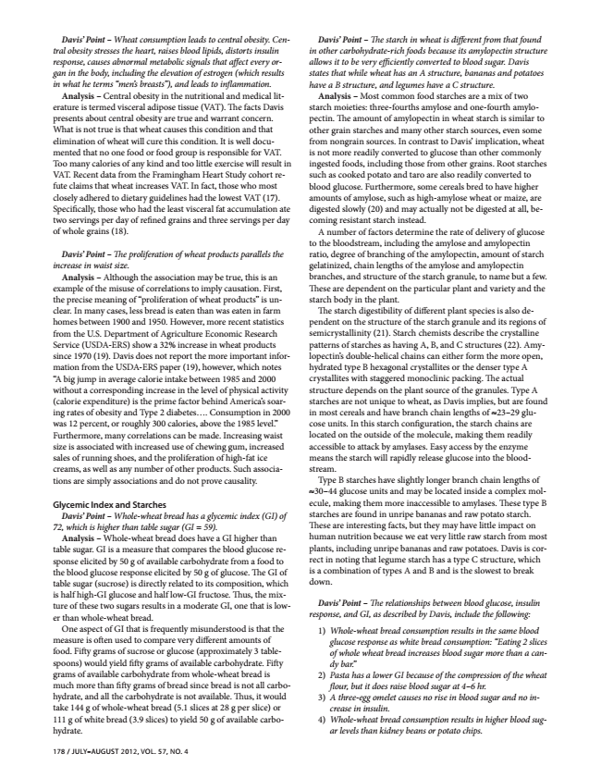
Davis’ Point – Wheat consumption leads to central obesity. Cen- tral obesity stresses the heart, raises blood lipids, distorts insulin response, causes abnormal metabolic signals that affect every or- gan in the body, including the elevation of estrogen (which results in what he terms “men’s breasts”), and leads to inflammation.
Analysis – Central obesity in the nutritional and medical lit- erature is termed visceral adipose tissue (VAT). The facts Davis presents about central obesity are true and warrant concern. What is not true is that wheat causes this condition and that elimination of wheat will cure this condition. It is well docu- mented that no one food or food group is responsible for VAT. Too many calories of any kind and too little exercise will result in VAT. Recent data from the Framingham Heart Study cohort re- fute claims that wheat increases VAT. In fact, those who most closely adhered to dietary guidelines had the lowest VAT (17). Specifically, those who had the least visceral fat accumulation ate two servings per day of refined grains and three servings per day of whole grains (18).
Davis’ Point – The proliferation of wheat products parallels the increase in waist size.
Analysis – Although the association may be true, this is an example of the misuse of correlations to imply causation. First, the precise meaning of “proliferation of wheat products” is un- clear. In many cases, less bread is eaten than was eaten in farm homes between 1900 and 1950. However, more recent statistics from the U.S. Department of Agriculture Economic Research Service (USDA-ERS) show a 32% increase in wheat products since 1970 (19). Davis does not report the more important infor- mation from the USDA-ERS paper (19), however, which notes “A big jump in average calorie intake between 1985 and 2000 without a corresponding increase in the level of physical activity (calorie expenditure) is the prime factor behind America’s soar- ing rates of obesity and Type 2 diabetes.... Consumption in 2000 was 12 percent, or roughly 300 calories, above the 1985 level.” Furthermore, many correlations can be made. Increasing waist size is associated with increased use of chewing gum, increased sales of running shoes, and the proliferation of high-fat ice creams, as well as any number of other products. Such associa- tions are simply associations and do not prove causality.
Glycemic Index and Starches
Davis’ Point – Whole-wheat bread has a glycemic index (GI) of 72, which is higher than table sugar (GI = 59).
Analysis – Whole-wheat bread does have a GI higher than table sugar. GI is a measure that compares the blood glucose re- sponse elicited by 50 g of available carbohydrate from a food to the blood glucose response elicited by 50 g of glucose. The GI of table sugar (sucrose) is directly related to its composition, which is half high-GI glucose and half low-GI fructose. Thus, the mix- ture of these two sugars results in a moderate GI, one that is low- er than whole-wheat bread.
One aspect of GI that is frequently misunderstood is that the measure is often used to compare very different amounts of food. Fifty grams of sucrose or glucose (approximately 3 table- spoons) would yield fifty grams of available carbohydrate. Fifty grams of available carbohydrate from whole-wheat bread is much more than fifty grams of bread since bread is not all carbo- hydrate, and all the carbohydrate is not available. Thus, it would take 144 g of whole-wheat bread (5.1 slices at 28 g per slice) or 111 g of white bread (3.9 slices) to yield 50 g of available carbo- hydrate.
178 / JULY–AUGUST 2012, VOL. 57, NO. 4
Davis’ Point – The starch in wheat is different from that found in other carbohydrate-rich foods because its amylopectin structure allows it to be very efficiently converted to blood sugar. Davis states that while wheat has an A structure, bananas and potatoes have a B structure, and legumes have a C structure.
Analysis – Most common food starches are a mix of two starch moieties: three-fourths amylose and one-fourth amylo- pectin. The amount of amylopectin in wheat starch is similar to other grain starches and many other starch sources, even some from nongrain sources. In contrast to Davis’ implication, wheat is not more readily converted to glucose than other commonly ingested foods, including those from other grains. Root starches such as cooked potato and taro are also readily converted to blood glucose. Furthermore, some cereals bred to have higher amounts of amylose, such as high-amylose wheat or maize, are digested slowly (20) and may actually not be digested at all, be- coming resistant starch instead.
A number of factors determine the rate of delivery of glucose to the bloodstream, including the amylose and amylopectin ratio, degree of branching of the amylopectin, amount of starch gelatinized, chain lengths of the amylose and amylopectin branches, and structure of the starch granule, to name but a few. These are dependent on the particular plant and variety and the starch body in the plant.
The starch digestibility of different plant species is also de- pendent on the structure of the starch granule and its regions of semicrystallinity (21). Starch chemists describe the crystalline patterns of starches as having A, B, and C structures (22). Amy- lopectin’s double-helical chains can either form the more open, hydrated type B hexagonal crystallites or the denser type A crystallites with staggered monoclinic packing. The actual structure depends on the plant source of the granules. Type A starches are not unique to wheat, as Davis implies, but are found in most cereals and have branch chain lengths of ≈23–29 glu- cose units. In this starch configuration, the starch chains are located on the outside of the molecule, making them readily accessible to attack by amylases. Easy access by the enzyme means the starch will rapidly release glucose into the blood- stream.
Type B starches have slightly longer branch chain lengths of ≈30–44 glucose units and may be located inside a complex mol- ecule, making them more inaccessible to amylases. These type B starches are found in unripe bananas and raw potato starch. These are interesting facts, but they may have little impact on human nutrition because we eat very little raw starch from most plants, including unripe bananas and raw potatoes. Davis is cor- rect in noting that legume starch has a type C structure, which is a combination of types A and B and is the slowest to break down.
Davis’ Point – The relationships between blood glucose, insulin response, and GI, as described by Davis, include the following:
1) Whole-wheat bread consumption results in the same blood
glucose response as white bread consumption: “Eating 2 slices of whole wheat bread increases blood sugar more than a can- dy bar.” 2) Pasta has a lower GI because of the compression of the wheat
flour, but it does raise blood sugar at 4–6 hr. 3) A three-egg omelet causes no rise in blood sugar and no in-
crease in insulin. 4) Whole-wheat bread consumption results in higher blood sug-
ar levels than kidney beans or potato chips.

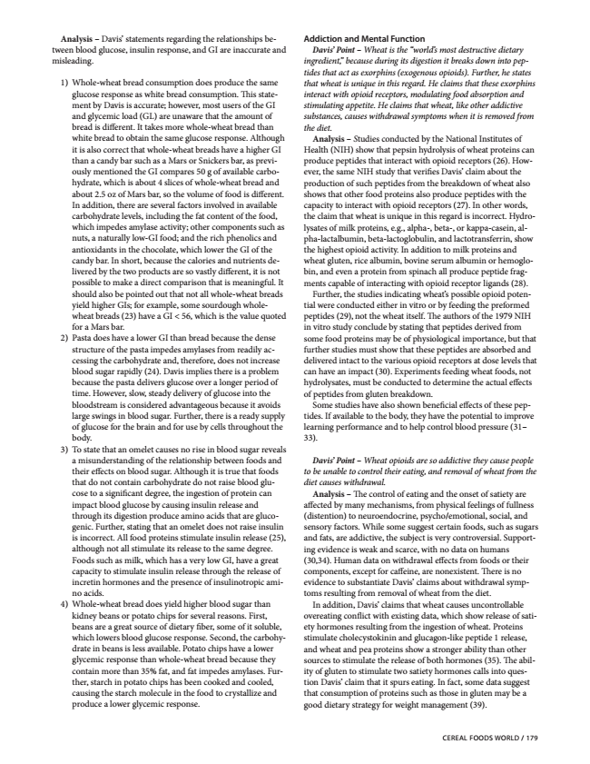
Analysis – Davis’ statements regarding the relationships be- tween blood glucose, insulin response, and GI are inaccurate and misleading.
1) Whole-wheat bread consumption does produce the same glucose response as white bread consumption. This state- ment by Davis is accurate; however, most users of the GI and glycemic load (GL) are unaware that the amount of bread is different. It takes more whole-wheat bread than white bread to obtain the same glucose response. Although it is also correct that whole-wheat breads have a higher GI than a candy bar such as a Mars or Snickers bar, as previ- ously mentioned the GI compares 50 g of available carbo- hydrate, which is about 4 slices of whole-wheat bread and about 2.5 oz of Mars bar, so the volume of food is different. In addition, there are several factors involved in available carbohydrate levels, including the fat content of the food, which impedes amylase activity; other components such as nuts, a naturally low-GI food; and the rich phenolics and antioxidants in the chocolate, which lower the GI of the candy bar. In short, because the calories and nutrients de- livered by the two products are so vastly different, it is not possible to make a direct comparison that is meaningful. It should also be pointed out that not all whole-wheat breads yield higher GIs; for example, some sourdough whole- wheat breads (23) have a GI < 56, which is the value quoted for a Mars bar. 2) Pasta does have a lower GI than bread because the dense structure of the pasta impedes amylases from readily ac- cessing the carbohydrate and, therefore, does not increase blood sugar rapidly (24). Davis implies there is a problem because the pasta delivers glucose over a longer period of time. However, slow, steady delivery of glucose into the bloodstream is considered advantageous because it avoids large swings in blood sugar. Further, there is a ready supply of glucose for the brain and for use by cells throughout the body. 3) To state that an omelet causes no rise in blood sugar reveals
a misunderstanding of the relationship between foods and their effects on blood sugar. Although it is true that foods that do not contain carbohydrate do not raise blood glu- cose to a significant degree, the ingestion of protein can impact blood glucose by causing insulin release and through its digestion produce amino acids that are gluco- genic. Further, stating that an omelet does not raise insulin is incorrect. All food proteins stimulate insulin release (25), although not all stimulate its release to the same degree. Foods such as milk, which has a very low GI, have a great capacity to stimulate insulin release through the release of incretin hormones and the presence of insulinotropic ami- no acids. 4) Whole-wheat bread does yield higher blood sugar than
kidney beans or potato chips for several reasons. First, beans are a great source of dietary fiber, some of it soluble, which lowers blood glucose response. Second, the carbohy- drate in beans is less available. Potato chips have a lower glycemic response than whole-wheat bread because they contain more than 35% fat, and fat impedes amylases. Fur- ther, starch in potato chips has been cooked and cooled, causing the starch molecule in the food to crystallize and produce a lower glycemic response.
Addiction and Mental Function
Davis’ Point – Wheat is the “world’s most destructive dietary ingredient,” because during its digestion it breaks down into pep- tides that act as exorphins (exogenous opioids). Further, he states that wheat is unique in this regard. He claims that these exorphins interact with opioid receptors, modulating food absorption and stimulating appetite. He claims that wheat, like other addictive substances, causes withdrawal symptoms when it is removed from the diet.
Analysis – Studies conducted by the National Institutes of Health (NIH) show that pepsin hydrolysis of wheat proteins can produce peptides that interact with opioid receptors (26). How- ever, the same NIH study that verifies Davis’ claim about the production of such peptides from the breakdown of wheat also shows that other food proteins also produce peptides with the capacity to interact with opioid receptors (27). In other words, the claim that wheat is unique in this regard is incorrect. Hydro- lysates of milk proteins, e.g., alpha-, beta-, or kappa-casein, al- pha-lactalbumin, beta-lactoglobulin, and lactotransferrin, show the highest opioid activity. In addition to milk proteins and wheat gluten, rice albumin, bovine serum albumin or hemoglo- bin, and even a protein from spinach all produce peptide frag- ments capable of interacting with opioid receptor ligands (28).
Further, the studies indicating wheat’s possible opioid poten- tial were conducted either in vitro or by feeding the preformed peptides (29), not the wheat itself. The authors of the 1979 NIH in vitro study conclude by stating that peptides derived from some food proteins may be of physiological importance, but that further studies must show that these peptides are absorbed and delivered intact to the various opioid receptors at dose levels that can have an impact (30). Experiments feeding wheat foods, not hydrolysates, must be conducted to determine the actual effects of peptides from gluten breakdown.
Some studies have also shown beneficial effects of these pep- tides. If available to the body, they have the potential to improve learning performance and to help control blood pressure (31– 33).
Davis’ Point – Wheat opioids are so addictive they cause people to be unable to control their eating, and removal of wheat from the diet causes withdrawal.
Analysis – The control of eating and the onset of satiety are affected by many mechanisms, from physical feelings of fullness (distention) to neuroendocrine, psycho/emotional, social, and sensory factors. While some suggest certain foods, such as sugars and fats, are addictive, the subject is very controversial. Support- ing evidence is weak and scarce, with no data on humans (30,34). Human data on withdrawal effects from foods or their components, except for caffeine, are nonexistent. There is no evidence to substantiate Davis’ claims about withdrawal symp- toms resulting from removal of wheat from the diet.
In addition, Davis’ claims that wheat causes uncontrollable overeating conflict with existing data, which show release of sati- ety hormones resulting from the ingestion of wheat. Proteins stimulate cholecystokinin and glucagon-like peptide 1 release, and wheat and pea proteins show a stronger ability than other sources to stimulate the release of both hormones (35). The abil- ity of gluten to stimulate two satiety hormones calls into ques- tion Davis’ claim that it spurs eating. In fact, some data suggest that consumption of proteins such as those in gluten may be a good dietary strategy for weight management (39).
CEREAL FOODS WORLD / 179

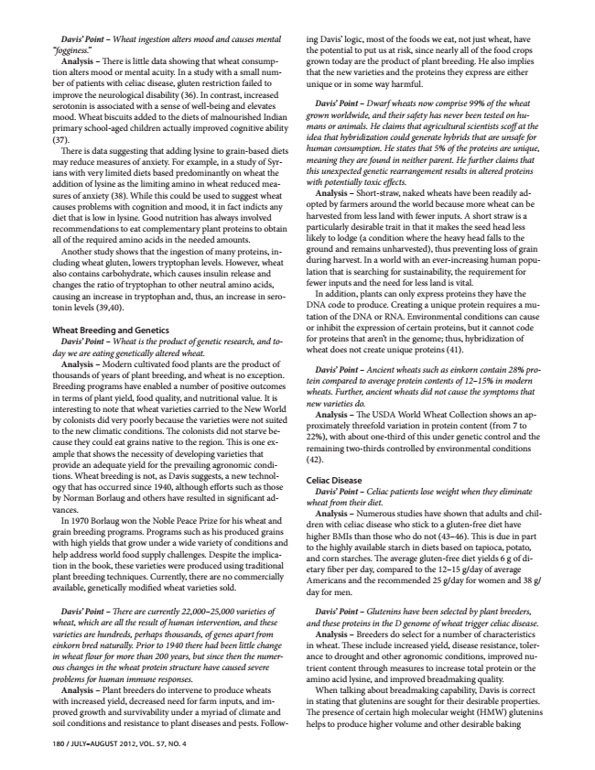
Davis’ Point – Wheat ingestion alters mood and causes mental “fogginess.”
Analysis – There is little data showing that wheat consump- tion alters mood or mental acuity. In a study with a small num- ber of patients with celiac disease, gluten restriction failed to improve the neurological disability (36). In contrast, increased serotonin is associated with a sense of well-being and elevates mood. Wheat biscuits added to the diets of malnourished Indian primary school-aged children actually improved cognitive ability (37).
There is data suggesting that adding lysine to grain-based diets may reduce measures of anxiety. For example, in a study of Syr- ians with very limited diets based predominantly on wheat the addition of lysine as the limiting amino in wheat reduced mea- sures of anxiety (38). While this could be used to suggest wheat causes problems with cognition and mood, it in fact indicts any diet that is low in lysine. Good nutrition has always involved recommendations to eat complementary plant proteins to obtain all of the required amino acids in the needed amounts.
Another study shows that the ingestion of many proteins, in- cluding wheat gluten, lowers tryptophan levels. However, wheat also contains carbohydrate, which causes insulin release and changes the ratio of tryptophan to other neutral amino acids, causing an increase in tryptophan and, thus, an increase in sero- tonin levels (39,40).
Wheat Breeding and Genetics
Davis’ Point – Wheat is the product of genetic research, and to- day we are eating genetically altered wheat.
Analysis – Modern cultivated food plants are the product of thousands of years of plant breeding, and wheat is no exception. Breeding programs have enabled a number of positive outcomes in terms of plant yield, food quality, and nutritional value. It is interesting to note that wheat varieties carried to the New World by colonists did very poorly because the varieties were not suited to the new climatic conditions. The colonists did not starve be- cause they could eat grains native to the region. This is one ex- ample that shows the necessity of developing varieties that provide an adequate yield for the prevailing agronomic condi- tions. Wheat breeding is not, as Davis suggests, a new technol- ogy that has occurred since 1940, although efforts such as those by Norman Borlaug and others have resulted in significant ad- vances.
In 1970 Borlaug won the Noble Peace Prize for his wheat and grain breeding programs. Programs such as his produced grains with high yields that grow under a wide variety of conditions and help address world food supply challenges. Despite the implica- tion in the book, these varieties were produced using traditional plant breeding techniques. Currently, there are no commercially available, genetically modified wheat varieties sold.
Davis’ Point – There are currently 22,000–25,000 varieties of wheat, which are all the result of human intervention, and these varieties are hundreds, perhaps thousands, of genes apart from einkorn bred naturally. Prior to 1940 there had been little change in wheat flour for more than 200 years, but since then the numer- ous changes in the wheat protein structure have caused severe problems for human immune responses.
Analysis – Plant breeders do intervene to produce wheats with increased yield, decreased need for farm inputs, and im- proved growth and survivability under a myriad of climate and soil conditions and resistance to plant diseases and pests. Follow-
180 / JULY–AUGUST 2012, VOL. 57, NO. 4
ing Davis’ logic, most of the foods we eat, not just wheat, have the potential to put us at risk, since nearly all of the food crops grown today are the product of plant breeding. He also implies that the new varieties and the proteins they express are either unique or in some way harmful.
Davis’ Point – Dwarf wheats now comprise 99% of the wheat grown worldwide, and their safety has never been tested on hu- mans or animals. He claims that agricultural scientists scoff at the idea that hybridization could generate hybrids that are unsafe for human consumption. He states that 5% of the proteins are unique, meaning they are found in neither parent. He further claims that this unexpected genetic rearrangement results in altered proteins with potentially toxic effects.
Analysis – Short-straw, naked wheats have been readily ad- opted by farmers around the world because more wheat can be harvested from less land with fewer inputs. A short straw is a particularly desirable trait in that it makes the seed head less likely to lodge (a condition where the heavy head falls to the ground and remains unharvested), thus preventing loss of grain during harvest. In a world with an ever-increasing human popu- lation that is searching for sustainability, the requirement for fewer inputs and the need for less land is vital.
In addition, plants can only express proteins they have the DNA code to produce. Creating a unique protein requires a mu- tation of the DNA or RNA. Environmental conditions can cause or inhibit the expression of certain proteins, but it cannot code for proteins that aren’t in the genome; thus, hybridization of wheat does not create unique proteins (41).
Davis’ Point – Ancient wheats such as einkorn contain 28% pro- tein compared to average protein contents of 12–15% in modern wheats. Further, ancient wheats did not cause the symptoms that new varieties do.
Analysis – The USDA World Wheat Collection shows an ap- proximately threefold variation in protein content (from 7 to 22%), with about one-third of this under genetic control and the remaining two-thirds controlled by environmental conditions (42).
Celiac Disease
Davis’ Point – Celiac patients lose weight when they eliminate wheat from their diet.
Analysis – Numerous studies have shown that adults and chil- dren with celiac disease who stick to a gluten-free diet have higher BMIs than those who do not (43–46). This is due in part to the highly available starch in diets based on tapioca, potato, and corn starches. The average gluten-free diet yields 6 g of di- etary fiber per day, compared to the 12–15 g/day of average Americans and the recommended 25 g/day for women and 38 g/ day for men.
Davis’ Point – Glutenins have been selected by plant breeders, and these proteins in the D genome of wheat trigger celiac disease.
Analysis – Breeders do select for a number of characteristics in wheat. These include increased yield, disease resistance, toler- ance to drought and other agronomic conditions, improved nu- trient content through measures to increase total protein or the amino acid lysine, and improved breadmaking quality.
When talking about breadmaking capability, Davis is correct in stating that glutenins are sought for their desirable properties. The presence of certain high molecular weight (HMW) glutenins helps to produce higher volume and other desirable baking

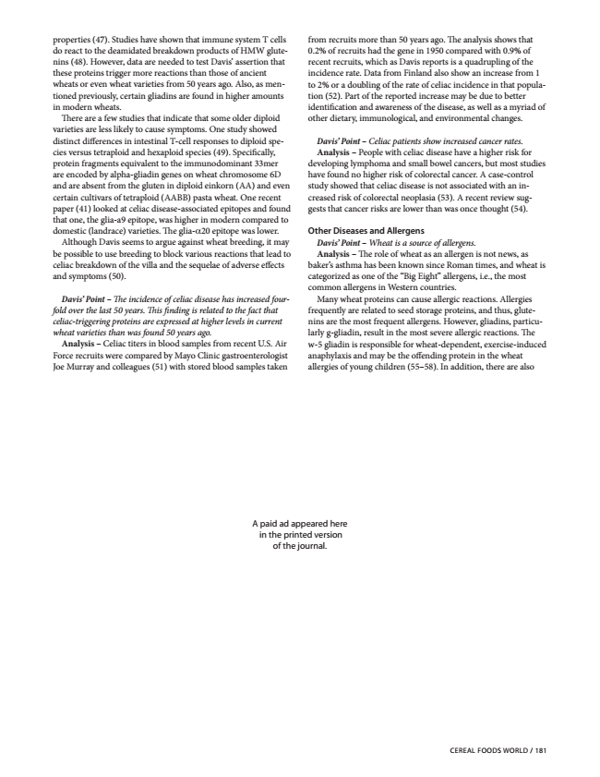
properties (47). Studies have shown that immune system T cells do react to the deamidated breakdown products of HMW glute- nins (48). However, data are needed to test Davis’ assertion that these proteins trigger more reactions than those of ancient wheats or even wheat varieties from 50 years ago. Also, as men- tioned previously, certain gliadins are found in higher amounts in modern wheats.
There are a few studies that indicate that some older diploid varieties are less likely to cause symptoms. One study showed distinct differences in intestinal T-cell responses to diploid spe- cies versus tetraploid and hexaploid species (49). Specifically, protein fragments equivalent to the immunodominant 33mer are encoded by alpha-gliadin genes on wheat chromosome 6D and are absent from the gluten in diploid einkorn (AA) and even certain cultivars of tetraploid (AABB) pasta wheat. One recent paper (41) looked at celiac disease-associated epitopes and found that one, the glia-a9 epitope, was higher in modern compared to domestic (landrace) varieties. The glia-α20 epitope was lower.
Although Davis seems to argue against wheat breeding, it may be possible to use breeding to block various reactions that lead to celiac breakdown of the villa and the sequelae of adverse effects and symptoms (50).
Davis’ Point – The incidence of celiac disease has increased four- fold over the last 50 years. This finding is related to the fact that celiac-triggering proteins are expressed at higher levels in current wheat varieties than was found 50 years ago.
Analysis – Celiac titers in blood samples from recent U.S. Air Force recruits were compared by Mayo Clinic gastroenterologist Joe Murray and colleagues (51) with stored blood samples taken
from recruits more than 50 years ago. The analysis shows that 0.2% of recruits had the gene in 1950 compared with 0.9% of recent recruits, which as Davis reports is a quadrupling of the incidence rate. Data from Finland also show an increase from 1 to 2% or a doubling of the rate of celiac incidence in that popula- tion (52). Part of the reported increase may be due to better identification and awareness of the disease, as well as a myriad of other dietary, immunological, and environmental changes.
Davis’ Point – Celiac patients show increased cancer rates. Analysis – People with celiac disease have a higher risk for developing lymphoma and small bowel cancers, but most studies have found no higher risk of colorectal cancer. A case-control study showed that celiac disease is not associated with an in- creased risk of colorectal neoplasia (53). A recent review sug- gests that cancer risks are lower than was once thought (54).
Other Diseases and Allergens
Davis’ Point – Wheat is a source of allergens. Analysis – The role of wheat as an allergen is not news, as baker’s asthma has been known since Roman times, and wheat is categorized as one of the “Big Eight” allergens, i.e., the most common allergens in Western countries.
Many wheat proteins can cause allergic reactions. Allergies frequently are related to seed storage proteins, and thus, glute- nins are the most frequent allergens. However, gliadins, particu- larly g-gliadin, result in the most severe allergic reactions. The w-5 gliadin is responsible for wheat-dependent, exercise-induced anaphylaxis and may be the offending protein in the wheat allergies of young children (55–58). In addition, there are also
A paid ad appeared here in the printed version of the journal.
CEREAL FOODS WORLD / 181

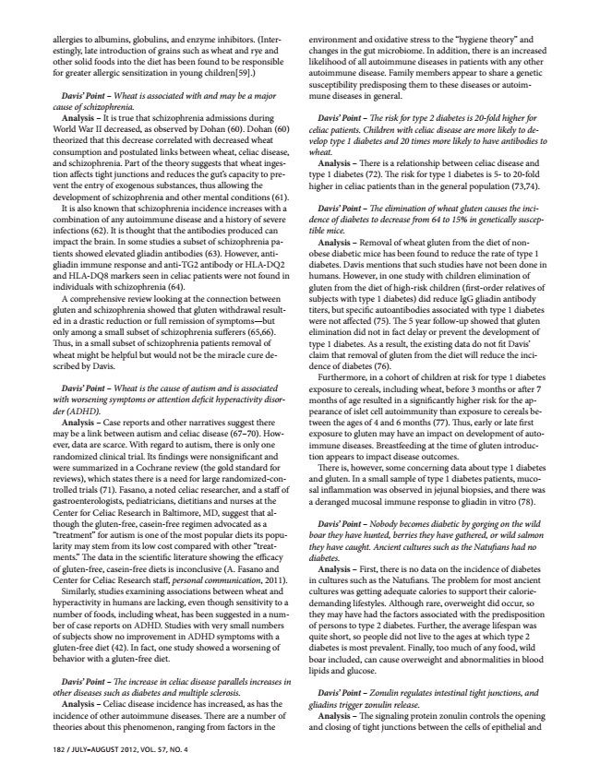
allergies to albumins, globulins, and enzyme inhibitors. (Inter- estingly, late introduction of grains such as wheat and rye and other solid foods into the diet has been found to be responsible for greater allergic sensitization in young children[59].)
Davis’ Point – Wheat is associated with and may be a major cause of schizophrenia.
Analysis – It is true that schizophrenia admissions during World War II decreased, as observed by Dohan (60). Dohan (60) theorized that this decrease correlated with decreased wheat consumption and postulated links between wheat, celiac disease, and schizophrenia. Part of the theory suggests that wheat inges- tion affects tight junctions and reduces the gut’s capacity to pre- vent the entry of exogenous substances, thus allowing the development of schizophrenia and other mental conditions (61).
It is also known that schizophrenia incidence increases with a combination of any autoimmune disease and a history of severe infections (62). It is thought that the antibodies produced can impact the brain. In some studies a subset of schizophrenia pa- tients showed elevated gliadin antibodies (63). However, anti- gliadin immune response and anti-TG2 antibody or HLA-DQ2 and HLA-DQ8 markers seen in celiac patients were not found in individuals with schizophrenia (64).
A comprehensive review looking at the connection between gluten and schizophrenia showed that gluten withdrawal result- ed in a drastic reduction or full remission of symptoms—but only among a small subset of schizophrenia sufferers (65,66). Thus, in a small subset of schizophrenia patients removal of wheat might be helpful but would not be the miracle cure de- scribed by Davis.
Davis’ Point – Wheat is the cause of autism and is associated with worsening symptoms or attention deficit hyperactivity disor- der (ADHD).
Analysis – Case reports and other narratives suggest there may be a link between autism and celiac disease (67–70). How- ever, data are scarce. With regard to autism, there is only one randomized clinical trial. Its findings were nonsignificant and were summarized in a Cochrane review (the gold standard for reviews), which states there is a need for large randomized-con- trolled trials (71). Fasano, a noted celiac researcher, and a staff of gastroenterologists, pediatricians, dietitians and nurses at the Center for Celiac Research in Baltimore, MD, suggest that al- though the gluten-free, casein-free regimen advocated as a “treatment” for autism is one of the most popular diets its popu- larity may stem from its low cost compared with other “treat- ments.” The data in the scientific literature showing the efficacy of gluten-free, casein-free diets is inconclusive (A. Fasano and Center for Celiac Research staff, personal communication, 2011).
Similarly, studies examining associations between wheat and hyperactivity in humans are lacking, even though sensitivity to a number of foods, including wheat, has been suggested in a num- ber of case reports on ADHD. Studies with very small numbers of subjects show no improvement in ADHD symptoms with a gluten-free diet (42). In fact, one study showed a worsening of behavior with a gluten-free diet.
Davis’ Point – The increase in celiac disease parallels increases in other diseases such as diabetes and multiple sclerosis.
Analysis – Celiac disease incidence has increased, as has the incidence of other autoimmune diseases. There are a number of theories about this phenomenon, ranging from factors in the
182 / JULY–AUGUST 2012, VOL. 57, NO. 4
environment and oxidative stress to the “hygiene theory” and changes in the gut microbiome. In addition, there is an increased likelihood of all autoimmune diseases in patients with any other autoimmune disease. Family members appear to share a genetic susceptibility predisposing them to these diseases or autoim- mune diseases in general.
Davis’ Point – The risk for type 2 diabetes is 20-fold higher for celiac patients. Children with celiac disease are more likely to de- velop type 1 diabetes and 20 times more likely to have antibodies to wheat.
Analysis – There is a relationship between celiac disease and type 1 diabetes (72). The risk for type 1 diabetes is 5- to 20-fold higher in celiac patients than in the general population (73,74).
Davis’ Point – The elimination of wheat gluten causes the inci- dence of diabetes to decrease from 64 to 15% in genetically suscep- tible mice.
Analysis – Removal of wheat gluten from the diet of non- obese diabetic mice has been found to reduce the rate of type 1 diabetes. Davis mentions that such studies have not been done in humans. However, in one study with children elimination of gluten from the diet of high-risk children (first-order relatives of subjects with type 1 diabetes) did reduce IgG gliadin antibody titers, but specific autoantibodies associated with type 1 diabetes were not affected (75). The 5 year follow-up showed that gluten elimination did not in fact delay or prevent the development of type 1 diabetes. As a result, the existing data do not fit Davis’ claim that removal of gluten from the diet will reduce the inci- dence of diabetes (76).
Furthermore, in a cohort of children at risk for type 1 diabetes exposure to cereals, including wheat, before 3 months or after 7 months of age resulted in a significantly higher risk for the ap- pearance of islet cell autoimmunity than exposure to cereals be- tween the ages of 4 and 6 months (77). Thus, early or late first exposure to gluten may have an impact on development of auto- immune diseases. Breastfeeding at the time of gluten introduc- tion appears to impact disease outcomes.
There is, however, some concerning data about type 1 diabetes and gluten. In a small sample of type 1 diabetes patients, muco- sal inflammation was observed in jejunal biopsies, and there was a deranged mucosal immune response to gliadin in vitro (78).
Davis’ Point – Nobody becomes diabetic by gorging on the wild boar they have hunted, berries they have gathered, or wild salmon they have caught. Ancient cultures such as the Natufians had no diabetes.
Analysis – First, there is no data on the incidence of diabetes in cultures such as the Natufians. The problem for most ancient cultures was getting adequate calories to support their calorie- demanding lifestyles. Although rare, overweight did occur, so they may have had the factors associated with the predisposition of persons to type 2 diabetes. Further, the average lifespan was quite short, so people did not live to the ages at which type 2 diabetes is most prevalent. Finally, too much of any food, wild boar included, can cause overweight and abnormalities in blood lipids and glucose.
Davis’ Point – Zonulin regulates intestinal tight junctions, and gliadins trigger zonulin release.
Analysis – The signaling protein zonulin controls the opening and closing of tight junctions between the cells of epithelial and

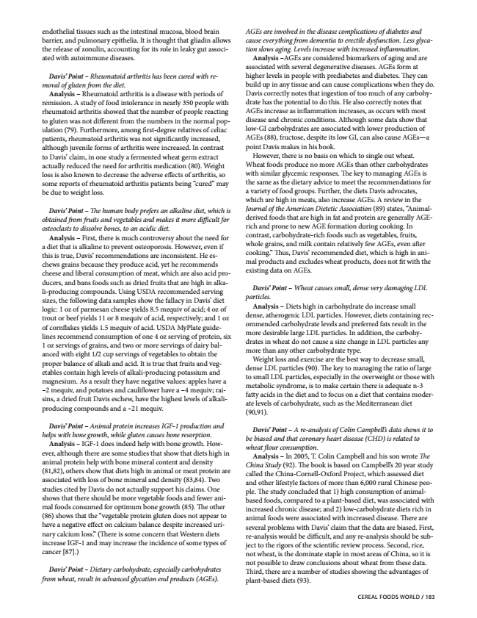
endothelial tissues such as the intestinal mucosa, blood brain barrier, and pulmonary epithelia. It is thought that gliadin allows the release of zonulin, accounting for its role in leaky gut associ- ated with autoimmune diseases.
Davis’ Point – Rheumatoid arthritis has been cured with re- moval of gluten from the diet.
Analysis – Rheumatoid arthritis is a disease with periods of remission. A study of food intolerance in nearly 350 people with rheumatoid arthritis showed that the number of people reacting to gluten was not different from the numbers in the normal pop- ulation (79). Furthermore, among first-degree relatives of celiac patients, rheumatoid arthritis was not significantly increased, although juvenile forms of arthritis were increased. In contrast to Davis’ claim, in one study a fermented wheat germ extract actually reduced the need for arthritis medication (80). Weight loss is also known to decrease the adverse effects of arthritis, so some reports of rheumatoid arthritis patients being “cured” may be due to weight loss.
Davis’ Point – The human body prefers an alkaline diet, which is obtained from fruits and vegetables and makes it more difficult for osteoclasts to dissolve bones, to an acidic diet.
Analysis – First, there is much controversy about the need for a diet that is alkaline to prevent osteoporosis. However, even if this is true, Davis’ recommendations are inconsistent. He es- chews grains because they produce acid, yet he recommends cheese and liberal consumption of meat, which are also acid pro- ducers, and bans foods such as dried fruits that are high in alka- li-producing compounds. Using USDA recommended serving sizes, the following data samples show the fallacy in Davis’ diet logic: 1 oz of parmesan cheese yields 8.5 mequiv of acid; 4 oz of trout or beef yields 11 or 8 mequiv of acid, respectively; and 1 oz of cornflakes yields 1.5 mequiv of acid. USDA MyPlate guide- lines recommend consumption of one 4 oz serving of protein, six 1 oz servings of grains, and two or more servings of dairy bal- anced with eight 1/2 cup servings of vegetables to obtain the proper balance of alkali and acid. It is true that fruits and veg- etables contain high levels of alkali-producing potassium and magnesium. As a result they have negative values: apples have a –2 mequiv, and potatoes and cauliflower have a –4 mequiv; rai- sins, a dried fruit Davis eschew, have the highest levels of alkali- producing compounds and a –21 mequiv.
Davis’ Point – Animal protein increases IGF-1 production and helps with bone growth, while gluten causes bone resorption.
Analysis – IGF-1 does indeed help with bone growth. How- ever, although there are some studies that show that diets high in animal protein help with bone mineral content and density (81,82), others show that diets high in animal or meat protein are associated with loss of bone mineral and density (83,84). Two studies cited by Davis do not actually support his claims. One shows that there should be more vegetable foods and fewer ani- mal foods consumed for optimum bone growth (85). The other (86) shows that the “vegetable protein gluten does not appear to have a negative effect on calcium balance despite increased uri- nary calcium loss.” (There is some concern that Western diets increase IGF-1 and may increase the incidence of some types of cancer [87].)
Davis’ Point – Dietary carbohydrate, especially carbohydrates from wheat, result in advanced glycation end products (AGEs).
AGEs are involved in the disease complications of diabetes and cause everything from dementia to erectile dysfunction. Less glyca- tion slows aging. Levels increase with increased inflammation.
Analysis –AGEs are considered biomarkers of aging and are associated with several degenerative diseases. AGEs form at higher levels in people with prediabetes and diabetes. They can build up in any tissue and can cause complications when they do. Davis correctly notes that ingestion of too much of any carbohy- drate has the potential to do this. He also correctly notes that AGEs increase as inflammation increases, as occurs with most disease and chronic conditions. Although some data show that low-GI carbohydrates are associated with lower production of AGEs (88), fructose, despite its low GI, can also cause AGEs—a point Davis makes in his book.
However, there is no basis on which to single out wheat. Wheat foods produce no more AGEs than other carbohydrates with similar glycemic responses. The key to managing AGEs is the same as the dietary advice to meet the recommendations for a variety of food groups. Further, the diets Davis advocates, which are high in meats, also increase AGEs. A review in the Journal of the American Dietetic Association (89) states, “Animal- derived foods that are high in fat and protein are generally AGE- rich and prone to new AGE formation during cooking. In contrast, carbohydrate-rich foods such as vegetables, fruits, whole grains, and milk contain relatively few AGEs, even after cooking.” Thus, Davis’ recommended diet, which is high in ani- mal products and excludes wheat products, does not fit with the existing data on AGEs.
Davis’ Point – Wheat causes small, dense very damaging LDL particles.
Analysis – Diets high in carbohydrate do increase small dense, atherogenic LDL particles. However, diets containing rec- ommended carbohydrate levels and preferred fats result in the more desirable large LDL particles. In addition, the carbohy- drates in wheat do not cause a size change in LDL particles any more than any other carbohydrate type.
Weight loss and exercise are the best way to decrease small, dense LDL particles (90). The key to managing the ratio of large to small LDL particles, especially in the overweight or those with metabolic syndrome, is to make certain there is adequate n-3 fatty acids in the diet and to focus on a diet that contains moder- ate levels of carbohydrate, such as the Mediterranean diet (90,91).
Davis’ Point – A re-analysis of Colin Campbell’s data shows it to be biased and that coronary heart disease (CHD) is related to wheat flour consumption.
Analysis – In 2005, T. Colin Campbell and his son wrote The China Study (92). The book is based on Campbell’s 20 year study called the China-Cornell-Oxford Project, which assessed diet and other lifestyle factors of more than 6,000 rural Chinese peo- ple. The study concluded that 1) high consumption of animal- based foods, compared to a plant-based diet, was associated with increased chronic disease; and 2) low-carbohydrate diets rich in animal foods were associated with increased disease. There are several problems with Davis’ claim that the data are biased. First, re-analysis would be difficult, and any re-analysis should be sub- ject to the rigors of the scientific review process. Second, rice, not wheat, is the dominate staple in most areas of China, so it is not possible to draw conclusions about wheat from these data. Third, there are a number of studies showing the advantages of plant-based diets (93).
CEREAL FOODS WORLD / 183

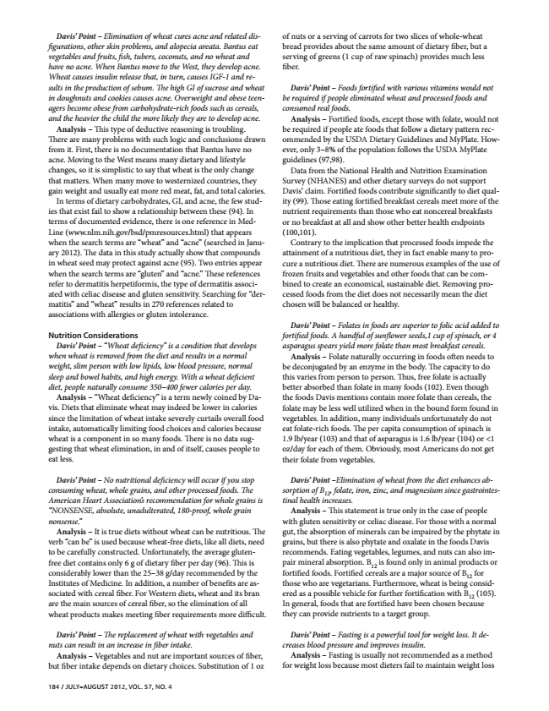
Davis’ Point – Elimination of wheat cures acne and related dis- figurations, other skin problems, and alopecia areata. Bantus eat vegetables and fruits, fish, tubers, coconuts, and no wheat and have no acne. When Bantus move to the West, they develop acne. Wheat causes insulin release that, in turn, causes IGF-1 and re- sults in the production of sebum. The high GI of sucrose and wheat in doughnuts and cookies causes acne. Overweight and obese teen- agers become obese from carbohydrate-rich foods such as cereals, and the heavier the child the more likely they are to develop acne.
Analysis – This type of deductive reasoning is troubling. There are many problems with such logic and conclusions drawn from it. First, there is no documentation that Bantus have no acne. Moving to the West means many dietary and lifestyle changes, so it is simplistic to say that wheat is the only change that matters. When many move to westernized countries, they gain weight and usually eat more red meat, fat, and total calories.
In terms of dietary carbohydrates, GI, and acne, the few stud- ies that exist fail to show a relationship between these (94). In terms of documented evidence, there is one reference in Med- Line (www.nlm.nih.gov/bsd/pmresources.html) that appears when the search terms are “wheat” and “acne” (searched in Janu- ary 2012). The data in this study actually show that compounds in wheat seed may protect against acne (95). Two entries appear when the search terms are “gluten” and “acne.” These references refer to dermatitis herpetiformis, the type of dermatitis associ- ated with celiac disease and gluten sensitivity. Searching for “der- matitis” and “wheat” results in 270 references related to associations with allergies or gluten intolerance.
Nutrition Considerations
Davis’ Point – “Wheat deficiency” is a condition that develops when wheat is removed from the diet and results in a normal weight, slim person with low lipids, low blood pressure, normal sleep and bowel habits, and high energy. With a wheat deficient diet, people naturally consume 350–400 fewer calories per day.
Analysis – “Wheat deficiency” is a term newly coined by Da- vis. Diets that eliminate wheat may indeed be lower in calories since the limitation of wheat intake severely curtails overall food intake, automatically limiting food choices and calories because wheat is a component in so many foods. There is no data sug- gesting that wheat elimination, in and of itself, causes people to eat less.
Davis’ Point – No nutritional deficiency will occur if you stop consuming wheat, whole grains, and other processed foods. The American Heart Association’s recommendation for whole grains is “NONSENSE, absolute, unadulterated, 180-proof, whole grain nonsense.”
Analysis – It is true diets without wheat can be nutritious. The verb “can be” is used because wheat-free diets, like all diets, need to be carefully constructed. Unfortunately, the average gluten- free diet contains only 6 g of dietary fiber per day (96). This is considerably lower than the 25–38 g/day recommended by the Institutes of Medicine. In addition, a number of benefits are as- sociated with cereal fiber. For Western diets, wheat and its bran are the main sources of cereal fiber, so the elimination of all wheat products makes meeting fiber requirements more difficult.
Davis’ Point – The replacement of wheat with vegetables and nuts can result in an increase in fiber intake.
Analysis – Vegetables and nut are important sources of fiber, but fiber intake depends on dietary choices. Substitution of 1 oz
184 / JULY–AUGUST 2012, VOL. 57, NO. 4
of nuts or a serving of carrots for two slices of whole-wheat bread provides about the same amount of dietary fiber, but a serving of greens (1 cup of raw spinach) provides much less fiber.
Davis’ Point – Foods fortified with various vitamins would not be required if people eliminated wheat and processed foods and consumed real foods.
Analysis – Fortified foods, except those with folate, would not be required if people ate foods that follow a dietary pattern rec- ommended by the USDA Dietary Guidelines and MyPlate. How- ever, only 3–8% of the population follows the USDA MyPlate guidelines (97,98).
Data from the National Health and Nutrition Examination Survey (NHANES) and other dietary surveys do not support Davis’ claim. Fortified foods contribute significantly to diet qual- ity (99). Those eating fortified breakfast cereals meet more of the nutrient requirements than those who eat noncereal breakfasts or no breakfast at all and show other better health endpoints (100,101).
Contrary to the implication that processed foods impede the attainment of a nutritious diet, they in fact enable many to pro- cure a nutritious diet. There are numerous examples of the use of frozen fruits and vegetables and other foods that can be com- bined to create an economical, sustainable diet. Removing pro- cessed foods from the diet does not necessarily mean the diet chosen will be balanced or healthy.
Davis’ Point – Folates in foods are superior to folic acid added to fortified foods. A handful of sunflower seeds,1 cup of spinach, or 4 asparagus spears yield more folate than most breakfast cereals.
Analysis – Folate naturally occurring in foods often needs to be deconjugated by an enzyme in the body. The capacity to do this varies from person to person. Thus, free folate is actually better absorbed than folate in many foods (102). Even though the foods Davis mentions contain more folate than cereals, the folate may be less well utilized when in the bound form found in vegetables. In addition, many individuals unfortunately do not eat folate-rich foods. The per capita consumption of spinach is 1.9 lb/year (103) and that of asparagus is 1.6 lb/year (104) or <1 oz/day for each of them. Obviously, most Americans do not get their folate from vegetables.
Davis’ Point –Elimination of wheat from the diet enhances ab- tinal sorption health of B
increases.
12
, folate, iron, zinc, and magnesium since gastrointes-
Analysis – This statement is true only in the case of people with gluten sensitivity or celiac disease. For those with a normal gut, the absorption of minerals can be impaired by the phytate in grains, but there is also phytate and oxalate in the foods Davis recommends. Eating vegetables, legumes, and nuts can also im- pair those fortified mineral who foods. are absorption. vegetarians. Fortified cereals B
12 Furthermore, is found are a major only wheat in source animal is being of products B
12
consid-
for
or
ered as a possible vehicle In general, foods that are for fortified further have fortification been chosen with because
B
12
(105).
they can provide nutrients to a target group.
Davis’ Point – Fasting is a powerful tool for weight loss. It de- creases blood pressure and improves insulin.
Analysis – Fasting is usually not recommended as a method for weight loss because most dieters fail to maintain weight loss

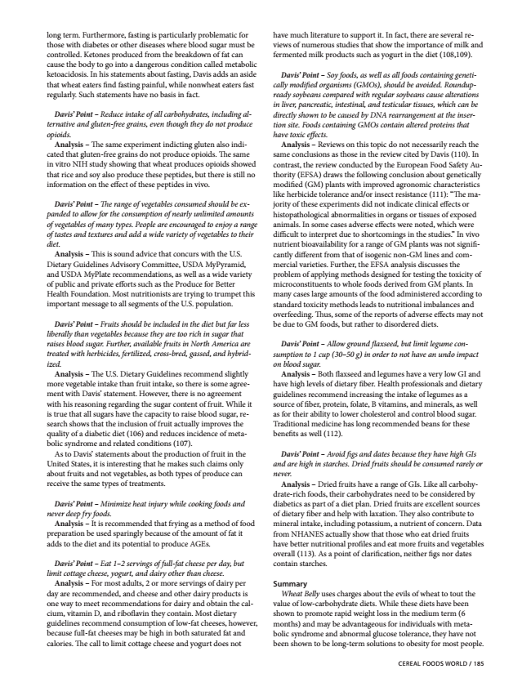
long term. Furthermore, fasting is particularly problematic for those with diabetes or other diseases where blood sugar must be controlled. Ketones produced from the breakdown of fat can cause the body to go into a dangerous condition called metabolic ketoacidosis. In his statements about fasting, Davis adds an aside that wheat eaters find fasting painful, while nonwheat eaters fast regularly. Such statements have no basis in fact.
Davis’ Point – Reduce intake of all carbohydrates, including al- ternative and gluten-free grains, even though they do not produce opioids.
Analysis – The same experiment indicting gluten also indi- cated that gluten-free grains do not produce opioids. The same in vitro NIH study showing that wheat produces opioids showed that rice and soy also produce these peptides, but there is still no information on the effect of these peptides in vivo.
Davis’ Point – The range of vegetables consumed should be ex- panded to allow for the consumption of nearly unlimited amounts of vegetables of many types. People are encouraged to enjoy a range of tastes and textures and add a wide variety of vegetables to their diet.
Analysis – This is sound advice that concurs with the U.S. Dietary Guidelines Advisory Committee, USDA MyPyramid, and USDA MyPlate recommendations, as well as a wide variety of public and private efforts such as the Produce for Better Health Foundation. Most nutritionists are trying to trumpet this important message to all segments of the U.S. population.
Davis’ Point – Fruits should be included in the diet but far less liberally than vegetables because they are too rich in sugar that raises blood sugar. Further, available fruits in North America are treated with herbicides, fertilized, cross-bred, gassed, and hybrid- ized.
Analysis – The U.S. Dietary Guidelines recommend slightly more vegetable intake than fruit intake, so there is some agree- ment with Davis’ statement. However, there is no agreement with his reasoning regarding the sugar content of fruit. While it is true that all sugars have the capacity to raise blood sugar, re- search shows that the inclusion of fruit actually improves the quality of a diabetic diet (106) and reduces incidence of meta- bolic syndrome and related conditions (107).
As to Davis’ statements about the production of fruit in the United States, it is interesting that he makes such claims only about fruits and not vegetables, as both types of produce can receive the same types of treatments.
Davis’ Point – Minimize heat injury while cooking foods and never deep fry foods.
Analysis – It is recommended that frying as a method of food preparation be used sparingly because of the amount of fat it adds to the diet and its potential to produce AGEs.
Davis’ Point – Eat 1–2 servings of full-fat cheese per day, but limit cottage cheese, yogurt, and dairy other than cheese.
Analysis – For most adults, 2 or more servings of dairy per day are recommended, and cheese and other dairy products is one way to meet recommendations for dairy and obtain the cal- cium, vitamin D, and riboflavin they contain. Most dietary guidelines recommend consumption of low-fat cheeses, however, because full-fat cheeses may be high in both saturated fat and calories. The call to limit cottage cheese and yogurt does not
have much literature to support it. In fact, there are several re- views of numerous studies that show the importance of milk and fermented milk products such as yogurt in the diet (108,109).
Davis’ Point – Soy foods, as well as all foods containing geneti- cally modified organisms (GMOs), should be avoided. Roundup- ready soybeans compared with regular soybeans cause alterations in liver, pancreatic, intestinal, and testicular tissues, which can be directly shown to be caused by DNA rearrangement at the inser- tion site. Foods containing GMOs contain altered proteins that have toxic effects.
Analysis – Reviews on this topic do not necessarily reach the same conclusions as those in the review cited by Davis (110). In contrast, the review conducted by the European Food Safety Au- thority (EFSA) draws the following conclusion about genetically modified (GM) plants with improved agronomic characteristics like herbicide tolerance and/or insect resistance (111): “The ma- jority of these experiments did not indicate clinical effects or histopathological abnormalities in organs or tissues of exposed animals. In some cases adverse effects were noted, which were difficult to interpret due to shortcomings in the studies.” In vivo nutrient bioavailability for a range of GM plants was not signifi- cantly different from that of isogenic non-GM lines and com- mercial varieties. Further, the EFSA analysis discusses the problem of applying methods designed for testing the toxicity of microconstituents to whole foods derived from GM plants. In many cases large amounts of the food administered according to standard toxicity methods leads to nutritional imbalances and overfeeding. Thus, some of the reports of adverse effects may not be due to GM foods, but rather to disordered diets.
Davis’ Point – Allow ground flaxseed, but limit legume con- sumption to 1 cup (30–50 g) in order to not have an undo impact on blood sugar.
Analysis – Both flaxseed and legumes have a very low GI and have high levels of dietary fiber. Health professionals and dietary guidelines recommend increasing the intake of legumes as a source of fiber, protein, folate, B vitamins, and minerals, as well as for their ability to lower cholesterol and control blood sugar. Traditional medicine has long recommended beans for these benefits as well (112).
Davis’ Point – Avoid figs and dates because they have high GIs and are high in starches. Dried fruits should be consumed rarely or never.
Analysis – Dried fruits have a range of GIs. Like all carbohy- drate-rich foods, their carbohydrates need to be considered by diabetics as part of a diet plan. Dried fruits are excellent sources of dietary fiber and help with laxation. They also contribute to mineral intake, including potassium, a nutrient of concern. Data from NHANES actually show that those who eat dried fruits have better nutritional profiles and eat more fruits and vegetables overall (113). As a point of clarification, neither figs nor dates contain starches.
Summary
Wheat Belly uses charges about the evils of wheat to tout the value of low-carbohydrate diets. While these diets have been shown to promote rapid weight loss in the medium term (6 months) and may be advantageous for individuals with meta- bolic syndrome and abnormal glucose tolerance, they have not been shown to be long-term solutions to obesity for most people.
CEREAL FOODS WORLD / 185

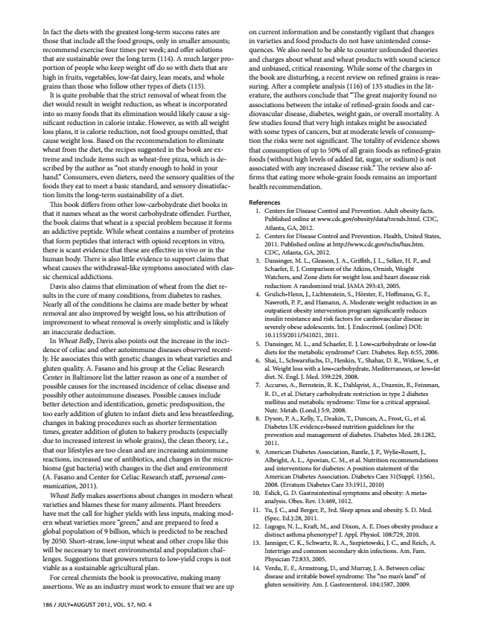
In fact the diets with the greatest long-term success rates are those that include all the food groups, only in smaller amounts; recommend exercise four times per week; and offer solutions that are sustainable over the long term (114). A much larger pro- portion of people who keep weight off do so with diets that are high in fruits, vegetables, low-fat dairy, lean meats, and whole grains than those who follow other types of diets (115).
It is quite probable that the strict removal of wheat from the diet would result in weight reduction, as wheat is incorporated into so many foods that its elimination would likely cause a sig- nificant reduction in calorie intake. However, as with all weight loss plans, it is calorie reduction, not food groups omitted, that cause weight loss. Based on the recommendation to eliminate wheat from the diet, the recipes suggested in the book are ex- treme and include items such as wheat-free pizza, which is de- scribed by the author as “not sturdy enough to hold in your hand.” Consumers, even dieters, need the sensory qualities of the foods they eat to meet a basic standard, and sensory dissatisfac- tion limits the long-term sustainability of a diet.
This book differs from other low-carbohydrate diet books in that it names wheat as the worst carbohydrate offender. Further, the book claims that wheat is a special problem because it forms an addictive peptide. While wheat contains a number of proteins that form peptides that interact with opioid receptors in vitro, there is scant evidence that these are effective in vivo or in the human body. There is also little evidence to support claims that wheat causes the withdrawal-like symptoms associated with clas- sic chemical addictions.
Davis also claims that elimination of wheat from the diet re- sults in the cure of many conditions, from diabetes to rashes. Nearly all of the conditions he claims are made better by wheat removal are also improved by weight loss, so his attribution of improvement to wheat removal is overly simplistic and is likely an inaccurate deduction.
In Wheat Belly, Davis also points out the increase in the inci- dence of celiac and other autoimmune diseases observed recent- ly. He associates this with genetic changes in wheat varieties and gluten quality. A. Fasano and his group at the Celiac Research Center in Baltimore list the latter reason as one of a number of possible causes for the increased incidence of celiac disease and possibly other autoimmune diseases. Possible causes include better detection and identification, genetic predisposition, the too early addition of gluten to infant diets and less breastfeeding, changes in baking procedures such as shorter fermentation times, greater addition of gluten to bakery products (especially due to increased interest in whole grains), the clean theory, i.e., that our lifestyles are too clean and are increasing autoimmune reactions, increased use of antibiotics, and changes in the micro- biome (gut bacteria) with changes in the diet and environment (A. Fasano and Center for Celiac Research staff, personal com- munication, 2011).
Wheat Belly makes assertions about changes in modern wheat varieties and blames these for many ailments. Plant breeders have met the call for higher yields with less inputs, making mod- ern wheat varieties more “green,” and are prepared to feed a global population of 9 billion, which is predicted to be reached by 2050. Short-straw, low-input wheat and other crops like this will be necessary to meet environmental and population chal- lenges. Suggestions that growers return to low-yield crops is not viable as a sustainable agricultural plan.
For cereal chemists the book is provocative, making many assertions. We as an industry must work to ensure that we are up
186 / JULY–AUGUST 2012, VOL. 57, NO. 4
on current information and be constantly vigilant that changes in varieties and food products do not have unintended conse- quences. We also need to be able to counter unfounded theories and charges about wheat and wheat products with sound science and unbiased, critical reasoning. While some of the charges in the book are disturbing, a recent review on refined grains is reas- suring. After a complete analysis (116) of 135 studies in the lit- erature, the authors conclude that “The great majority found no associations between the intake of refined-grain foods and car- diovascular disease, diabetes, weight gain, or overall mortality. A few studies found that very high intakes might be associated with some types of cancers, but at moderate levels of consump- tion the risks were not significant. The totality of evidence shows that consumption of up to 50% of all grain foods as refined-grain foods (without high levels of added fat, sugar, or sodium) is not associated with any increased disease risk.” The review also af- firms that eating more whole-grain foods remains an important health recommendation.
References
1. Centers for Disease Control and Prevention. Adult obesity facts.
Published online at www.cdc.gov/obesity/data/trends.html. CDC, Atlanta, GA, 2012. 2. Centers for Disease Control and Prevention. Health, United States,
2011. Published online at http://www.cdc.gov/nchs/hus.htm. CDC, Atlanta, GA, 2012. 3. Dansinger, M. L., Gleason, J. A., Griffith, J. L., Selker, H. P., and
Schaefer, E. J. Comparison of the Atkins, Ornish, Weight Watchers, and Zone diets for weight loss and heart disease risk reduction: A randomized trial. JAMA 293:43, 2005. 4. Grulich-Henn, J., Lichtenstein, S., Hörster, F., Hoffmann, G. F.,
Nawroth, P. P., and Hamann, A. Moderate weight reduction in an outpatient obesity intervention program significantly reduces insulin resistance and risk factors for cardiovascular disease in severely obese adolescents. Int. J. Endocrinol. (online) DOI: 10.1155/2011/541021, 2011. 5. Dansinger, M. L., and Schaefer, E. J. Low-carbohydrate or low-fat
diets for the metabolic syndrome? Curr. Diabetes. Rep. 6:55, 2006. 6. Shai, I., Schwarzfuchs, D., Henkin, Y., Shahar, D. R., Witkow, S., et al. Weight loss with a low-carbohydrate, Mediterranean, or low-fat diet. N. Engl. J. Med. 359:229, 2008. 7. Accurso, A., Bernstein, R. K., Dahlqvist, A., Draznin, B., Feinman, R. D., et al. Dietary carbohydrate restriction in type 2 diabetes mellitus and metabolic syndrome: Time for a critical appraisal. Nutr. Metab. (Lond.) 5:9, 2008. 8. Dyson, P. A., Kelly, T., Deakin, T., Duncan, A., Frost, G., et al.
Diabetes UK evidence-based nutrition guidelines for the prevention and management of diabetes. Diabetes Med. 28:1282, 2011. 9. American Diabetes Association, Bantle, J. P., Wylie-Rosett, J.,
Albright, A. L., Apovian, C. M., et al. Nutrition recommendations and interventions for diabetes: A position statement of the American Diabetes Association. Diabetes Care 31(Suppl. 1):S61, 2008. (Erratum Diabetes Care 33:1911, 2010) 10. Eslick, G. D. Gastrointestinal symptoms and obesity: A meta-
analysis. Obes. Rev. 13:469, 1012. 11. Yu, J. C., and Berger, P., 3rd. Sleep apnea and obesity. S. D. Med.
(Spec. Ed.):28, 2011. 12. Lugogo, N. L., Kraft, M., and Dixon, A. E. Does obesity produce a
distinct asthma phenotype? J. Appl. Physiol. 108:729, 2010. 13. Janniger, C. K., Schwartz, R. A., Szepietowski, J. C., and Reich, A. Intertrigo and common secondary skin infections. Am. Fam. Physician 72:833, 2005. 14. Verdu, E. F., Armstrong, D., and Murray, J. A. Between celiac disease and irritable bowel syndrome: The “no man’s land” of gluten sensitivity. Am. J. Gastroenterol. 104:1587, 2009.

